2022 9th International Power Electronics Systems and Applications (PESA)

Title
Hydrogen fuel cell electric vehicles: State of Art and outlooks

Abstract

Hydrogen Proton Exchange Membrane (PEM) fuel cell is considered today as a promising technology for low-carbon transport applications. The successful deployment of fuel cell technology in automotive sector is a key element to reach out the European Union’s CO2 emission goal by 2050. After years of developments by research institutions and enterprises, the automotive fuel cell technology has gradually introduced to the market since 2015. In this keynote, we will explore together the key technologies of modern commercial fuel cell electric vehicles, such as Toyota Mirai 1 and 2, Honda Clarity Fuel Cell, etc. The place of fuel cell technology in our future low-carbon transports and the main challenges will be discussed.

Brief Bio
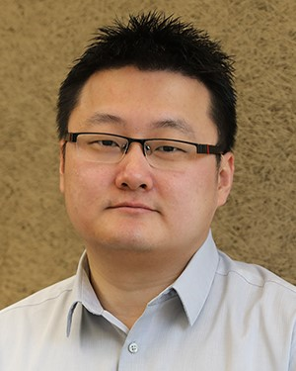
Fei Gao received the master’s degree in electrical and control system engineering, in 2007, and the Ph.D. degree in renewable energy with distinguished youth doctor reward in 2010, both from the University of Technology of Belfort-Montbe ́ liard (UTBM), Belfort, France.

He is currently an Associate Professor at the En- ergy Department, UTBM, France. He is the Head of the Energy Production Division, Department of En- ergy, UTBM.

Dr. Gao is the holder of the French research exper- tise bonus (PEDR) by the French Ministry of Higher Education and Research with A rank. He is also an Associate Editor of the IEEE TRANSACTIONS ON INDUSTRY APPLICATIONS and the IEEE TRANSACTIONS ON TRANSPORTATION ELECTRIFICATION, and the Chair of fuel cell modeling axis of the Fuel Cell Re- search Federation in France. He is elected in 2013 as Secretary of the Technical Committee on Transportation Electrification of the IEEE Industry Electronic Society.

